Even though it may not seem so, the command line is more powerful than windows explorer.

http://i.gyazo.com/aed8978b9afc74d850bb99e4d8990186.png

lists all files and directories in the working directory. 2014 and 2015 are directories and hardware.txt are the files at this level in the directory. If you cd to 2015 and type ls, it will show the files that are in 2015 instead.

http://i.gyazo.com/6738aff8207b6377eb326ecca548e886.png

This shows the path to the working directory. (Print Working Directory)

http://i.gyazo.com/38150a22567380343b7d81f321005afc.png

mkdir creates directory in the working directory

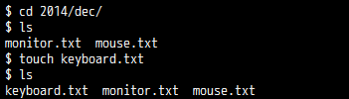

touch creates a file in the working directory (specify the type w/ the name)

